Dr. AVL. Sirisha is a research Scholar of JKR Astro Research Foundation. She pursued her M.Sc, M.phil, (Ph.D) Physics from Acharya Nagarjuna University, Guntur. She pursued her M.A Astrology from Potti Sreeramulu Telugu University. Presently working as Astro Consultant.

I am glad that I have got an opportunity to write an article on Yogi and Avayogi planets through JKR Astro Research Foundation.

**Yogi and Avayogi Planets**

The Yogi/ Avayogi was gradually developed in South India. The origin of Yogi and Avayogi is found in Nadi Astrology, it was coined by one H. R. Seshadri Iyer of India. Lately, it is used in many Jyotish Software.

***Yogi planet:*** This planet acts as a catalyst that helps in success and prosperity in life during their dasha period.

***Avayogi:*** This is just the opposite of Yogi planet which creates obstacles and hindrances in success and prosperity.

***Duplicate/Saha Yogi:*** This is just like a shadow of the Yogi planet. It helps the Yogi planet as we say that god helps those who help themselves.

***Calculation Of Yogi and Avayogis:***

***Yogi Point:*** It is the resultant longitude arrived at by adding 93 degrees and 20 minutes to the sum total of the longitudes of Sun and Moon.

***Yogi Planet:*** The nakshatra lord in which the Yoga Point is located will be called Yogi Planet. Yogi planet is also known as Yogi.

***Duplicate/Saha Yogi:*** It is the sign lord of Yogi Point.

***Avayogi Point:*** It is the resultant longitude arrived at by adding 6 signs 6 degrees and 40 minutes to the Yogi point. Simply we can say 6th nakshatra from Yoga nakshatra becomes Avayogi point.

***Avayogi Planet:*** The nakshatra lord in which the Avayogi point is located will be called Avayogi Planet. Avayogi Planet is also known as Avayogi.

***Some points of observation for Yogi/ Avayogi Planets:***

1. If the ascendant degree of the horoscope is placed in the nakshatra of the Yogi, the person will be predisposed towards material prosperity all his life.
2. If the ascendant degree of the horoscope is placed in the nakshatra of the Avayogi, the person will tend toward material deprivation and shall face misery in life.
3. If Yogi is placed in the ascendant, there is a marked tendency towards material prosperity.
4. If Avayogi is placed in the ascendant, there is a marked tendency towards material deprivation and shall face misery in life.
5. If Yogi is the lord of the Ascendant and well placed, the native is pre disposed towards material prosperity.
6. If Avayogi is the lord of the Ascendant, the native will tend toward material deprivation and misery if Avayogi is strong but not so if it is weak or is posited in Dagdha rashi.
7. Yogi position in Navamsha lagna is good and Avayogi position is bad.
8. A connection between the Yogi and the Saha Yogi by PAC creates a powerful yoga for prosperity.
9. Any planet in the nakshatra of a Yogi will give good results.
10. Rahu/Ketu confer very auspicious results in their dashas if either conjoins Yogi or is posited in the nakshatra of Yogi.
11. Rahu/Ketu if placed with Avayogi planet or in the nakshatra of Avayogi is capable of giving excellent results.
12. Avayogi placed in the Rahu/Ketu nakshatra also gives good results.
13. A planet conjuncting or aspected by a Yogi becomes good, and with Avayogi it becomes bad.
14. An Avayogi in a good bhava or in nakshatra of a friendly planet gives bad results.
15. An Avayogi if posited in a bad (3, 6, 8 or 12) place or is in nakshatra of trik lord or of an inimical planet or is combust becomes good.
16. Avayogi if owns a dagdha rashi or is posited in a dagdha rashi or is in the nakshatra of lord of dagdha rashi, it becomes very auspicious.
17. Even though Yogi sits in a dagdha rashi can give good results.
18. An Avayogi conjuncting or in nakshatra of a Yogi/ Saha Yogi becomes good.
19. A Yogi always confer good results under any circumstances but loses some of its beneficence if it has connection with Avayogi by conjunction or stellar position.
20. A planet in the constellation of a Yogi becomes favourable but in that of Avayogi it is inauspicious.
21. Yogi planet is placed in a kendra/ trine gets the strength of producing good results during its MD/AD.
22. Sometimes Yogi planet behaves in a better way as compared to lagna nakshatra lord or any best-placed planet in the chart.
23. Transits of benefic planets over Yogi point brings a lot of fortune and prosperity in the life, and transit of malefic planets over the Avayogi point can cause hurdles.
24. MD/AD of Yogi planet or planets which are in the trines of the Yogi nakshatra can also bring prosperity.
25. Association of Avayogi with dasha lord is not good.
26. In transit, if Yogi is passing through good house will do good to that house, and if Avayogi passes through dusthana will do good.
27. In transit, dasanatha passing through Yogi nakshatra will do good and through Avayogi nakshatra will do bad.

***Example Chart:***

Gender: Female,DOB: 05 Dec 1983,TOB: 18:27 Hrs,POB: Amalapuram

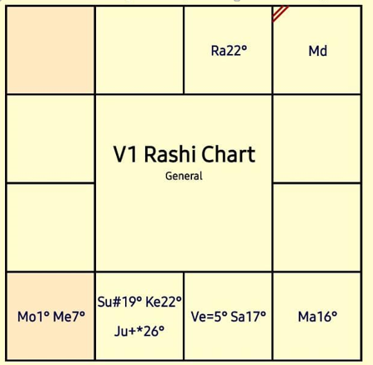

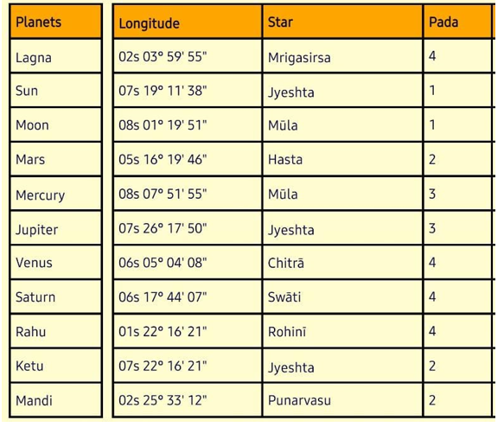

***Calculation Of Yogi and Avayogi Planets:***

Longitude of Sun: 07s 190 111 3811

Longitude of Moon: 08s 010 191 5111

Sum of Longitudes: 03s 200 311 2911

Add 93 degrees 20 minutes to the resultant Longitude

(03s 200 311 2911) + (930 201) = ***06s 230 511 2911*** - Yogi point

Yogi point is in Libra in Visakha star. Its lord Jupiter is Yogi planet. Its rashi lord Venus is Saha/ Duplicate Yogi. 6th nakshtra from Visakha is Uttarashada. Its lord Sun is Ava yogi planet.

***Application:***

But practical is never as simple as theory looks. Jupiter is the native’s Yogi planet and Sun is her Ava yogi planet. Sun is posited in 6th house along with Ketu and Yogi planet Jupiter. As said above point no: 15, Sun should be good. But in Sun/Rahu MD/AD, the native lost her father, disturbed family life and had health problems. At the same time, in Sun/Moon the native awarded M.Phil. degree and also bought a new home. In Sun/Mercury, the native completed M.A and finally in Sun/Venus the native got seat in Ph.D. In the Yogi planet Jupiter antar dashas, Venus/Jupiter, the native joined in her Post Graduation in a reputed University. In Sun/Jupiter, the native joined for another Post graduation degree and finally in Moon/Jupiter, the native pursued Ph.D. and awarded her Doctorate.

***Conclusion:***

So, it is again back to the same concept that Everything is in Addition and Nothing Cancels Anything. Yogi and Ava yogi planet would matter much in deciding results but their conjunction, aspects, dashas and antar dashas are also important.

***References:***

Practical Vedic Astrology by G.S. Agarwal

Lecture by Dr. T. S. Vasan, Lecture by Kapiel Raaj